Practico 1

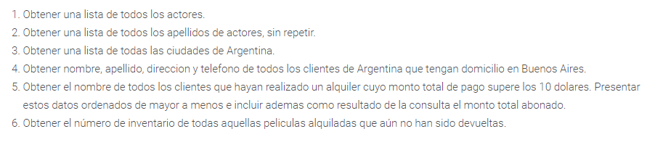

1 [SELECT](http://localhost/phpmyadmin/url.php?url=https://dev.mysql.com/doc/refman/8.0/en/select.html) * from actor;

2 [SELECT](http://localhost/phpmyadmin/url.php?url=https://dev.mysql.com/doc/refman/8.0/en/select.html) DISTINCT last_name from actor;

3 [SELECT](http://localhost/phpmyadmin/url.php?url=https://dev.mysql.com/doc/refman/8.0/en/select.html) DISTINCT city from city WHERE country_id [in](http://localhost/phpmyadmin/url.php?url=https://dev.mysql.com/doc/refman/8.0/en/comparison-operators.html%23function_in) ([SELECT](http://localhost/phpmyadmin/url.php?url=https://dev.mysql.com/doc/refman/8.0/en/select.html) country_id from country where country = "argentina" );

4 SELECT first_name, last_name, address from customer, address WHERE customer.address_id = address.address_id and city_id in (SELECT city_id from city WHERE city = "buenos aires");

5 [SELECT](http://localhost/phpmyadmin/url.php?url=https://dev.mysql.com/doc/refman/8.0/en/select.html) first_name, last_name, address from customer, address WHERE customer.address_id = address.address_id [and](http://localhost/phpmyadmin/url.php?url=https://dev.mysql.com/doc/refman/8.0/en/logical-operators.html%23operator_and) city_id [in](http://localhost/phpmyadmin/url.php?url=https://dev.mysql.com/doc/refman/8.0/en/comparison-operators.html%23function_in) ([SELECT](http://localhost/phpmyadmin/url.php?url=https://dev.mysql.com/doc/refman/8.0/en/select.html) city_id from city WHERE country_id [in](http://localhost/phpmyadmin/url.php?url=https://dev.mysql.com/doc/refman/8.0/en/comparison-operators.html%23function_in) ([SELECT](http://localhost/phpmyadmin/url.php?url=https://dev.mysql.com/doc/refman/8.0/en/select.html) country_id from country WHERE country = "argentina"));

(todas las ciudades de argentina son de bs as) / no hay ciudad cargada como buenos aires

6 [SELECT](http://localhost/phpmyadmin/url.php?url=https://dev.mysql.com/doc/refman/8.0/en/select.html) [COUNT](http://localhost/phpmyadmin/url.php?url=https://dev.mysql.com/doc/refman/8.0/en/aggregate-functions.html%23function_count)(film_id) FROM inventory where inventory_id [in](http://localhost/phpmyadmin/url.php?url=https://dev.mysql.com/doc/refman/8.0/en/comparison-operators.html%23function_in) ([SELECT](http://localhost/phpmyadmin/url.php?url=https://dev.mysql.com/doc/refman/8.0/en/select.html) inventory_id from rental WHERE Return_date = null);